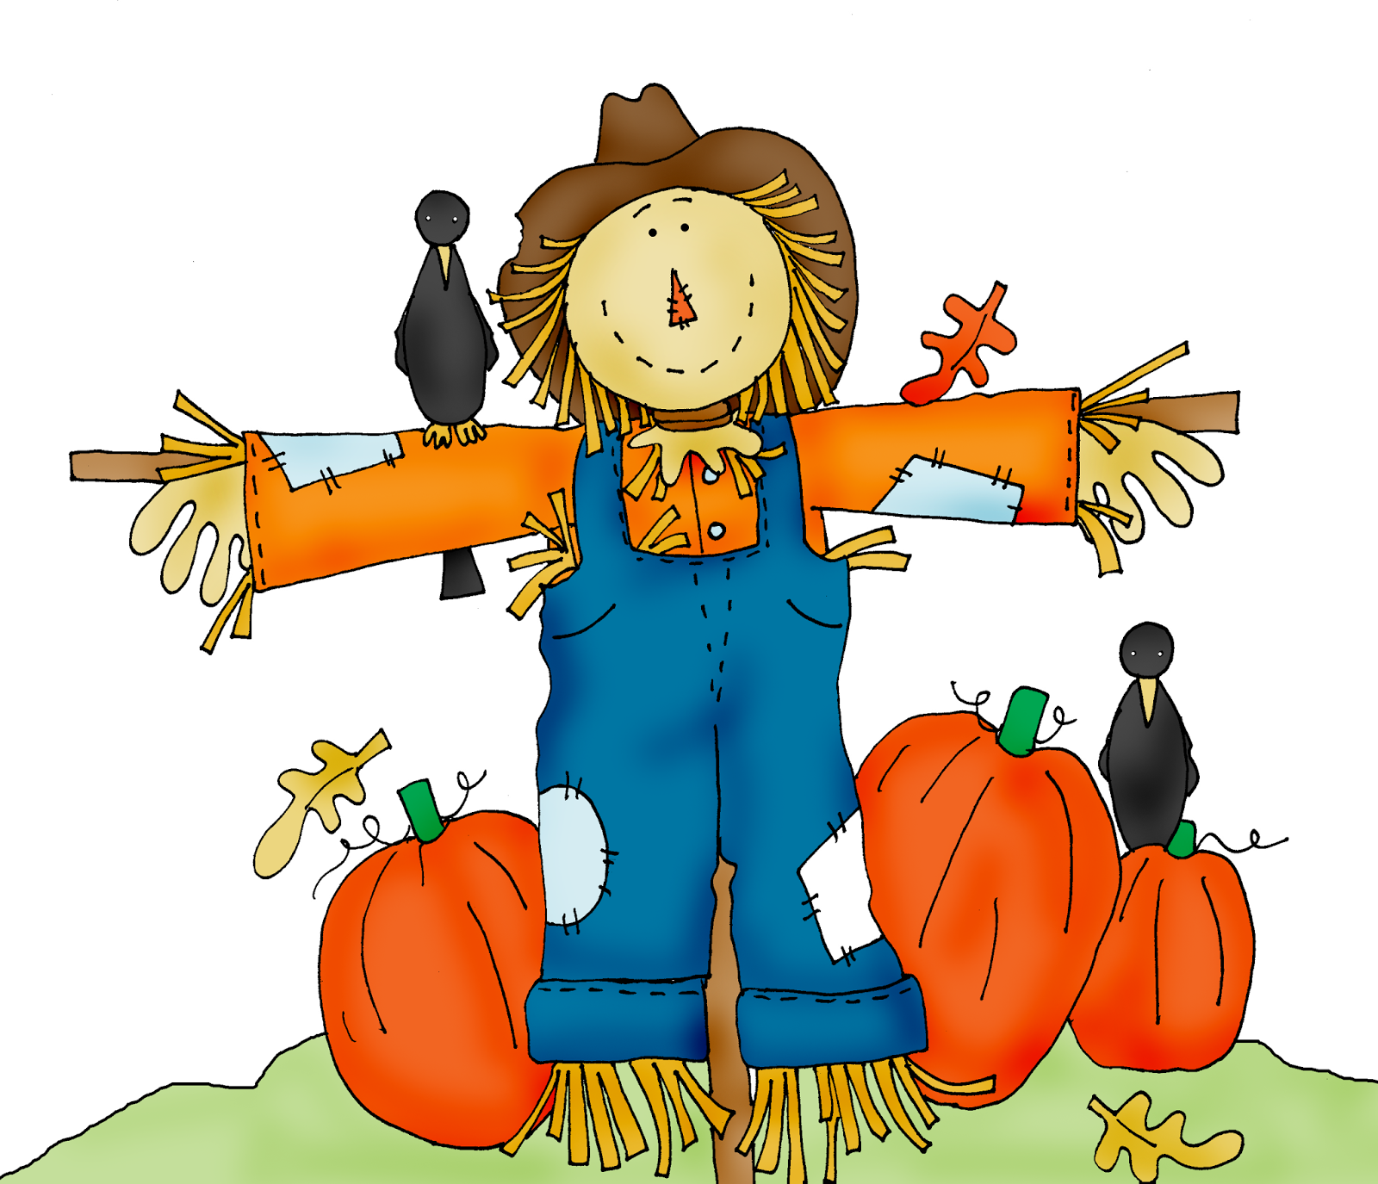
2022 Morgan County
Squarecrow Showcase

Morgan County Squarecrow Showcase

Entry Form

Name of Individual/Family/ Business/School/Church/Non-profit Organization/ Government:

______________________________________________________

Contact Name: __________________________________________

Phone: _____________ Email Address: __________________________

Street Address: __________________City _________________Zip_____

A non-refundable Entry fee must accompany the entry form.

Please check the appropriate competition category:

Make these entry checks payable to the Morgan County Tourism Alliance

_____ Family/Individual/School/Non-Profit ($20)

_____Church _____Group _____ Business (all $40)

* (Group includes: clubs, civic organizations, government office or agency)

Sponsorship: Please make $100 check payable to the Morgan County Tourism Alliance. ($40 entry fee is included in the $100).

_____ Sponsor ($100) Entry fee of $ is enclosed.

I have read and agree to abide to all terms and conditions pertaining to the 2021 Squarecrow Showcase and Contest.

___________________________ ___________________
Signature Date

Please submit your entry form to the Morgan County Tourism Alliance at 201 Court Street, Wartburg, TN 37887

